Arian Kharazmi – Database Management II – Assignment 03 – 9/25/2022

Please answer the questions below and submit you answer as a single document.

1. The table shown below is susceptible to update anomalies. Provide examples of how insertion, deletion, and modification anomalies could occur on this table.

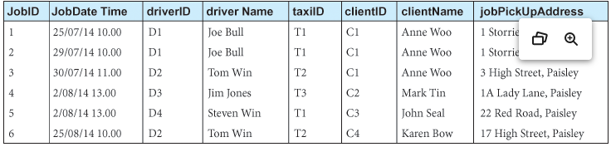

Insertion: Insertion would probably produce issues if you added for example: a new taxi driver. When you add a new taxi driver, you must make sure that the other columns are completed and filled up so that you do not end up with bad information that has been wrongly linked. This can happen if you accidentally place information in the wrong space, such as which driver is driving which cab.

Deletion: What you try to remove might have big impacts on the data. If you remove a driver_Name, it would remove all rows and presences of ‘Joe Bull’ for example. You must be careful as to what you wish to remove from the data, otherwise it can cause fundamental issues.

Modification: Updating information (modifying) must update the information in the other rows that contain that same information you wish to change. This maintains referential integrity. If you don’t, you will have issues relating to the integrity of the actual data, for example: In a database if you make a modification to the date of an event, you must modify (update) the data to the same value/attributes in the other rows that contain that event.

1. Describe and illustrate the process of normalizing the table shown below to 3NF relations. Identify the primary, alternate, and foreign keys in your 3NF relations. Clearly indicate the 1NF,2NF and 3NF relations

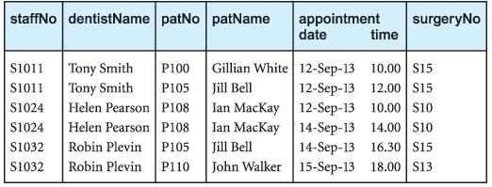

1st Normal Form:

Composite Primary Key: staffNo, patNo (identifies each row)

Unique Key: dentistName, patName (non-primary)

2nd Normal Form:

Primary Key: staffNo, patNo

Foreign Key: staffNo, patNo

Staff, Patient, Appointment – three tables (depending on primary key: staffNo, patNo)

StaffNo, dentistName are partial dependencies (primary key defined other attributes)

patNo, patName are partial dependencies (primary key defined other attributes)

3rd Normal Form:

Primary Key: staffNo, patNo

Foreign Key: staffNo, patNo

Staff – Patient, Appointment – three tables (depending on primary key: staffNo, patNo)

StaffNo, dentistName are partial dependencies (primary key defined other attributes)

patNo, patName are partial dependencies (primary key defined other attributes)